

Antonine University
Faculty of Engineering

Theory of Computation Technical Report

Presented To:
Dr. Ahmad KASSEM
Prepared By:
Eliane JREIJ ID: 202212259
Daniel KABBOUT ID: 202210815

- Project Objectives and Scope

Objective:
The project implements a small compiler pipeline with a Win32 GUI that supports lexical analysis, parsing, semantic analysis, and code translation to Python. Additionally, it provides visualizations of automata (NFA/DFA) and parse trees, with export capabilities for both text and image artifacts.

Scope:
- Lexical analysis (tokenization) of source programs.
- Parsing to generate an Abstract Syntax Tree (AST).
- Semantic analysis for error and warning detection.
- Translation of the AST into Python code.
- Visualization of parse trees, NFAs, and DFAs with trace highlighting.
- Export of all textual and graphical artifacts (BMP/text files).
- User interface supporting Dark/Light mode and theme customization.

Screenshot placeholders:
- GUI main window
- Tabs for Parse Tree, DFA, and NFA

- Design and Implementation

2.1 Overall Architecture

The project consists of two main layers:
- Backend (compiler logic) – Handles lexing, parsing, semantic analysis, translation, and automata operations.
- GUI (Win32 interface) – Implements the user interface with controls, canvases, and interaction handlers.

Data Flow:
- Source code entered in the left edit box.
- Lexing produces a TokenList.
- Parsing converts tokens to an ASTNode tree.
- Semantic analysis verifies symbols and produces errors/warnings.
- Translation outputs Python code if no semantic errors.
- Visualizations:
  - Parse tree: node graph with edges
  - NFA: nondeterministic automaton with epsilon transitions
  - DFA: deterministic automaton derived from NFA
  - Optional trace highlighting

Screenshot placeholders:
- Lexing tab showing tokens
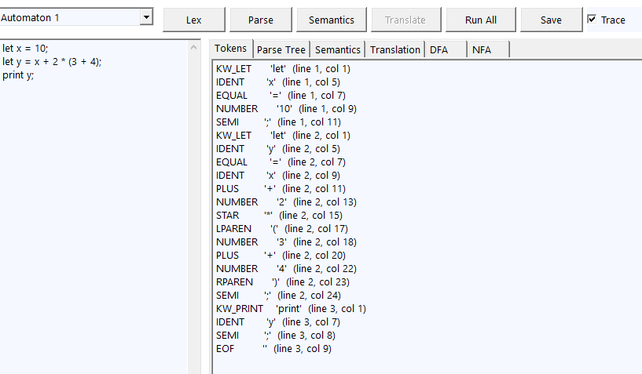
- Parsing tab with parse tree
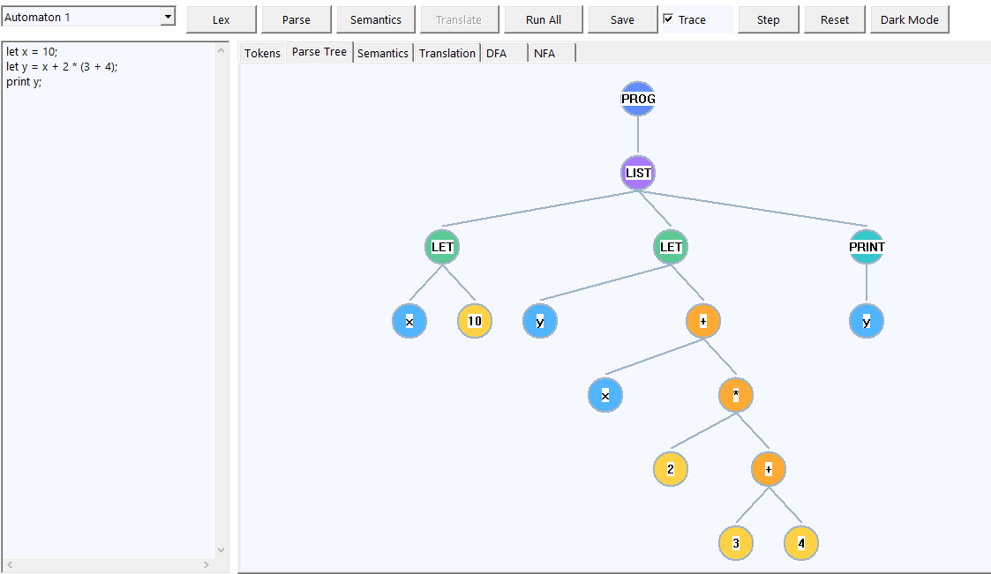

2.2 Files and Responsibilities

Build System:
- CMakeLists.txt builds backend and GUI; links with user32, gdi32, Comctl32; optionally includes UI/win_main.cpp.

GUI Layer:
- UI/win_main.cpp: entry point; instantiates UiApp.
- UI/ui_app.h/cpp: main window, controls, drawing functions, trace handling, and event callbacks.
- Drawing functions:
  - drawParseTree() – displays AST nodes and edges
  - drawNfa() / drawDfa() – draws states, transitions, legends, start arrows, self-loops, and highlights traces

Screenshot placeholders:
- NFA visualization
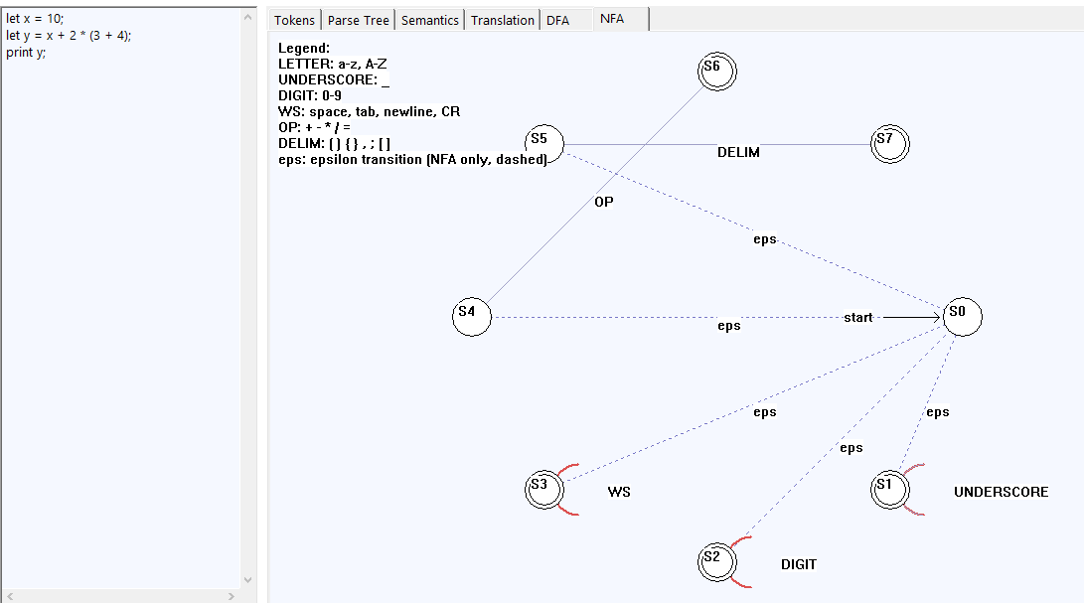
- DFA visualization
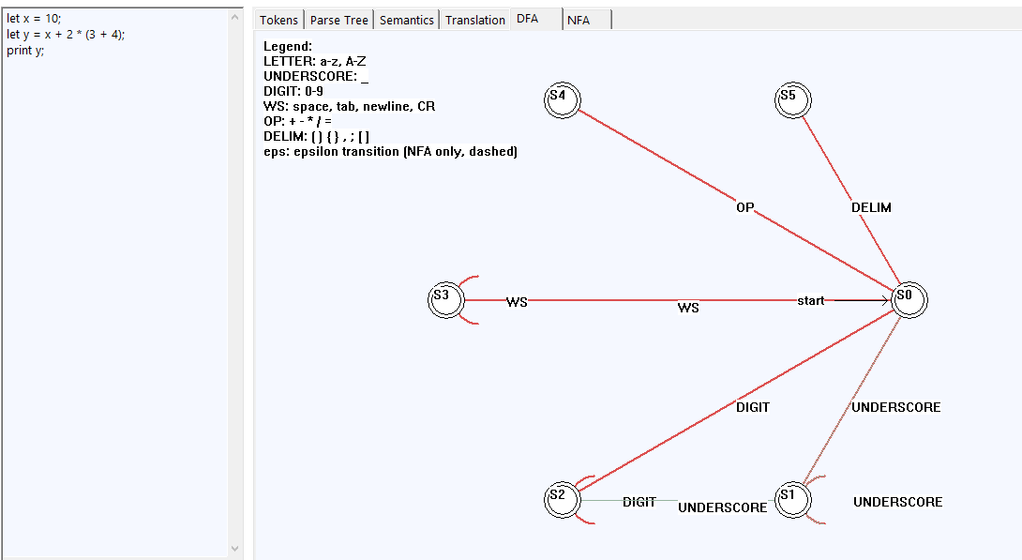

2.3 Lexing and Automata
- lexer.h/cpp: defines TokenType, Token, and TokenList.
- Lexical analysis uses a DFA to classify characters.
- automaton.h/cpp: implements DFA structure and character classification.
- nfa.h/cpp: builds NFAs for identifiers, numbers, operators, whitespace, and delimiters. Supports determinization to DFA.

Screenshot placeholders:
- WITHOUT Trace highlighting
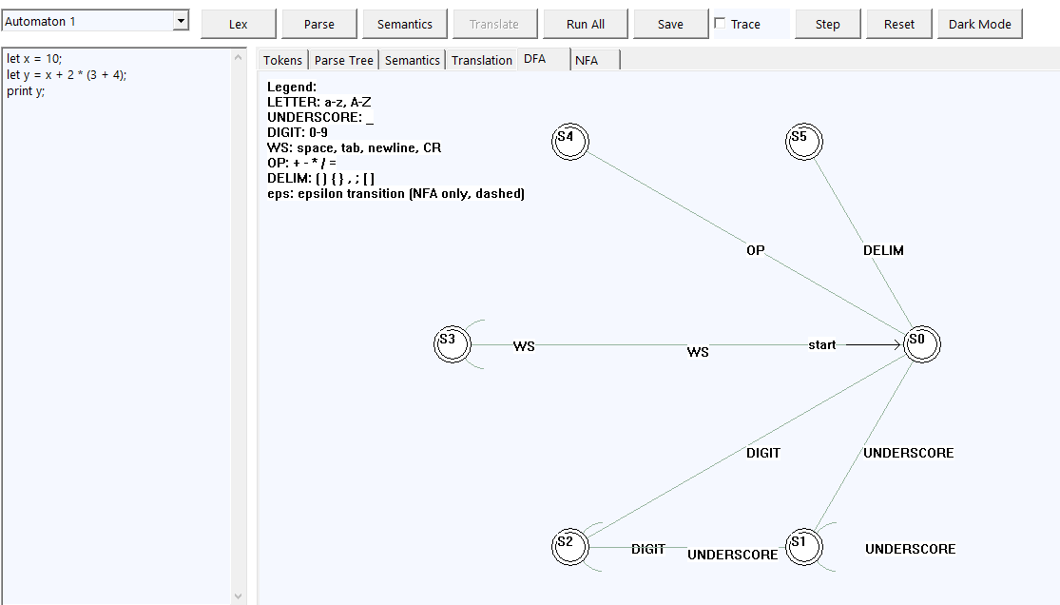
- WITH Trace highlighting
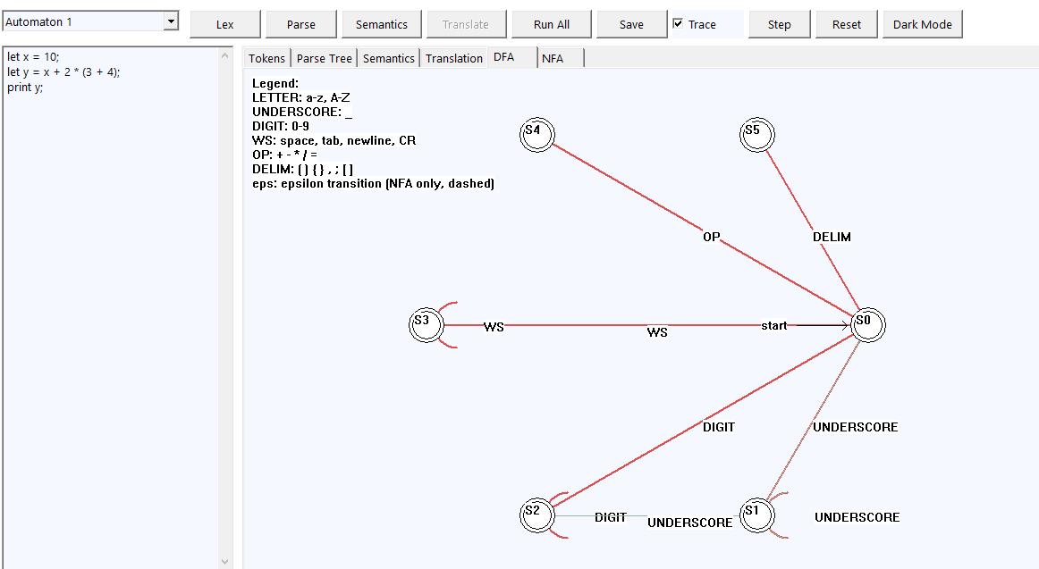

2.4 Parsing and AST
- Recursive-descent parser (parser.h/cpp) produces AST nodes for programs, statements, expressions, and factors.
- Handles let assignments and print statements.
- AST nodes store type, text, line/column info, and child links.

2.5 Semantic Analysis
- semantic.h/cpp manages SymbolTable, errors, and warnings.
- Checks for undefined identifiers and unused variables.
- Errors block translation; warnings do not.

Screenshot placeholders:
- Semantics tab highlighting errors (red) and warnings (yellow)
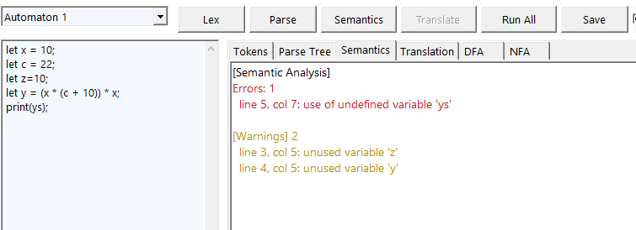

2.6 Translation
- translator.cpp traverses the AST and generates Python code.
- Only executed if semantic analysis passes.

Screenshot placeholders:
- Translation tab showing generated Python code
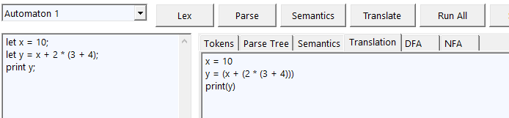

- Automatons and Grammars
- NFA: nondeterministic representation of token patterns (letters, digits, underscores, operators, punctuation, whitespace).
- DFA: determinized version of the NFA used for fast token recognition.
- Grammar: simple expression and statement grammar supporting:
  - let assignments
  - print statements
  - arithmetic expressions with + and *
  - parentheses for grouping
- Algorithms and Data Structures
- Lexing: DFA simulation to classify characters and generate tokens.
- Parsing: recursive-descent parser, building an AST tree with child/next pointers.
- Semantic Analysis: symbol table with lookup; error and warning lists.
- Translation: AST traversal to generate Python code.
- Automata Construction:
  - NFA construction per token type
  - Epsilon-closure and subset construction for DFA
  - Trace path marking via boolean edge tables
- Data Structures Used:
  - Trees: AST
  - Arrays: TokenList, DFA transition tables
  - Sets: NFA epsilon-closure and state sets
  - Structs/classes: Token, ASTNode, Automaton, NFA

- Test Cases and Results
  - Test Case 1:
Input : let x = 10;
let c = 22;
let y = (x * (c + 10)) * x;
print(y);
  - output: https://youtu.be/1SnHVYE7heM
  - Test Case 2:
Input :
  - output: 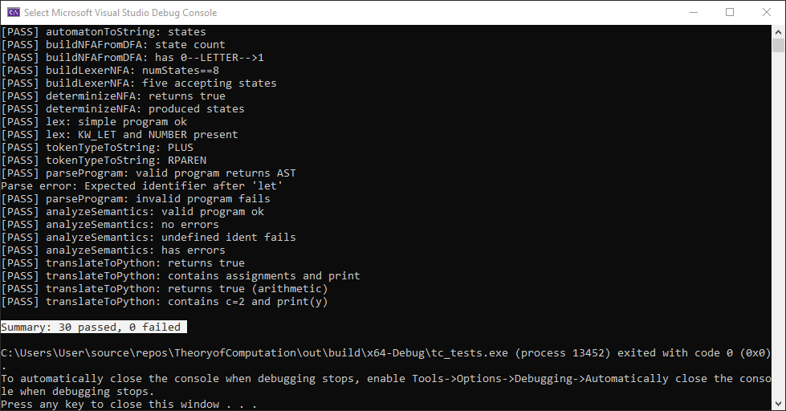

- Usage Instructions
- Enter source code in the left “Source” box.
- Click buttons in order:
  - Lex → shows tokens
  - Parse → builds AST and shows parse tree
  - Semantics → runs checks and shows messages
  - Translate → outputs Python if no errors
  - Run All → executes all stages automatically
- Switch tabs to view DFA/NFA drawings; use Trace/Step/Reset to visualize execution.
- Click Save to export text artifacts and BMP images.
- Use Dark Mode to toggle UI theme.

